INTRODUCTION TO PROPOSED SYSTEM

Motivation:

Accurate and easy to use online system for farm are of fundamental importance for successful operational forming. However still today many farmers do not know about various technology as well fertilizers. In particular for small to medium-size form and for multifunctional farming if a form is well managed in appropriate manner, then the farmer can get much profit. The growth of the global population coupled with a decline in natural resources.
Environmental conditions lead to food security becoming a major concern, these problems are motivators. In order to meet the current global needs of humidity, new solutions and technology are constantly being implemented. So, this online system for farm is very useful to lead the farming systems.

.
- Problem Statements:

A homogenous area should be delineated for the study. This is because the input and output structure depend very much upon the topographical, climatic and soil condition. One of the main problems of the farming is that of timing.
Most of pesticides fertilizers more than required quantity leads to rejection of the produced decrease agricultural. Heigh yielding variety of seeds, a chemical fertilizers injection etc. expensive and our farmers find it difficult to purchase these.

- Objectives:

- To enhance the economic development of all stake-holders.
- To improve nutritional standard for betterment of health.
- A whole-farm budget is used to estimate the expected income, expenses and profit.
- The enable farmers maximize their profit.
- Evaluate resources: Data about land, water, labour, plants and renewable resources are gathered to plan their exploitation in an efficient way that will produce the optimum result.

  - Project Scope:

- This system reducing the use of fertilizers and other harmful Agro chemical to provide pollution free. Healthy produce and environment to the society.
- Inspire young people to stay in rural areas and become future farmers.
- Maximum yield of all component enterprises to provide stable income.
- online farming system helps farmers to better understand the important factors such as water, vegetation and soil types.

  - Limitations:

- poor living conditions and hygiene for livestock.
- The need to provide for same measure of good security.
- Heigh capital costs may discourage farmer to not adopt this method of farming.
- Production costs may be higher because farmer need more workers.

2. SYSTEM ANALYSIS
- Existing System:
This type of all system is informed that can be used for various farming process. It satisfies the farmer requirement. The System is easy to understand by the farmers. Be easy to operate for everyone. Have a good user interface and be expandable. Arrange and Schedule with proper time and management. It is the study of farmer as a producer of food and other raw materials. Who occupies a strategic position in the economic like of a country farm.
Online system for farm gives thrust and direction to farming improvement by providing useful information to farmers.

- Scope and Limitations of Existing System:

- In this system farmer can get the knowledge about the proper farming techniques.
- The farmers adopt and learn the new technologies and get more educated about the farming.
- Improve standard of living of farming community.
- Agriculture directly or indirectly supports the Indian population livelihood. Agricultural segment plays an important role in the economic activity of a country.
- Agricultural is the most significant source of is come for the central and government.

  - Limitation of Existing System

- Farmers faced tough times, the prices and the need to purchase expensive machinery, expensive fertilizers and pesticides.
- The farmers need the more labour to complete the work on time.
- Heigh capital costs may discourage farmers to not adopt this method of farming.
- Precision agricultural techniques are still under development and requires expert advice before actual implementation.

  - Stakeholder:
In some cases, study outline the democratic both also the practical potential in collaboration among stakeholder group research, advisers and farmers-arguing that deliberation will enhance the chance the chance of successful adoption of digital agricultural technologies.
There are two main types of stakeholders in project management, internal and external.
- Internal Stakeholder: These stakeholders are coming from within the house!!! Internal stakeholder are people are groups within the business, such as team member managers, executive and so on.

- External Stakeholder: External stakeholders are-as you can probably guess-people or groups outside the business. This includes customers, users, suppliers and investors.

Team Members :

Roll No. | Student Name
27 | Nikam Varuna Avinash
51 | Sawant Gayatri Shivaji
52 | Sawant Vasudha Hemant
53 | Nikam Pooja Nanaji
Team No. | 05

3. Requirement Analysis
a. Functional Requirements :

- Farmer can register and create his own account.
- The farmer could learn the technique how to use online system for farm.
- This system allows user to find out the farming information.
- Automated and simple to use methods for data processing.
- Agriculture faces a range of social and environmental challenges such as the growing demand for high-quality food products.
- Climate change and market globalization.
- Easy-to-use interface that doesn’t require advance training, support of documentation.
- This system requires user/farmer name and password compulsory.

b. Performance Requirements

- An online system for farm performance could be a platform that helps farmer track and optimize their farm operation.
- Crop monitoring: The system could be providing farmers with real -time data on their crops. Such a soil monture, plant growth. This could help farmer to make informed about the crop condition and give appropriate fertilizer to the crop and also any other precaution.
- Equipment monitoring: the platform could monitor the performance of farm equipment.
Ex. Rotavator, tiller.
- Collaboration tools: The platform could be provided collaboration tools for farmers to work together, share information and coordinate their operations.
- Increased productivity.
- Achieve sustainable growth.

c. Social Requirements

- An online system for farm social requirements could be a platform that connects farmers with social and community resources to meet the social and environmental responsibilities of their farm operations.
- The system could offer tools to assist farmers in meeting these requirements.
- The system could be designed to help farmers meet requirements related to labour, environment suitability and other social responsibilities.
- The system provides information for fertilizer to help farmer.
- This system helps farmer stay farmer on top of their responsibilities avoid potential peanuttier.

d. Data Collection

- Data collection is also becoming important for farmer to approach resource conservation at a wide scale rather than at the farm level.
- This gives more opportunities to work with other field experts.
- The information obtained can help farmers identity efficiencies that lead to higher productivity and profitability, lower input costs, and optimized fertilizer use.
- The more a farmer knows about his or her farm, the better their opportunities to strong then supply chain relationships

e. Software / Hardware Specification Hardware requirements:

For the Server:
- Processor: Standard processor with a speed of 1.6 GHz or more
- RAM: 256 MB RAM or more
- Hard Disk: 3 GB or more

For the Client:
- Processor: Standard processor with a speed of 1.6 GHz or more
- RAM: 256 MB RAM or more
- Hard Disk: 3 GB or more
Software requirements:

For the Server:
- Operating System: Linux
- Frontend: PHP, CSS, JavaScript
- Backend: PostgreSQL (Version 8)
- Server: Apache 2. Wamp Server, zamp Server (Any)
For the Client:
- Operating System: Linux
- Browsers: Any

4. System Design

a. Data Dictionary

Sr.no | Table Name | Description
1 | User Table | User table contains User name, first Name, last Name, Address, mobile number, password, email address, gender, age, contact number, Aadhar number, bank name, bank number, farm area, soil type.
2 | Contact Table | Contact table contains contact id, shop name, contact number, email and message.
3 | Crop Table | Crop Table contains crop type, quantity, season, growth and water supply to the crops.
4 | Seeds Table | Seeds table contains seeds type, timing, quantity, cost, growth.
5 | Vegetable Table | Vegetables table contain vegetable type, quantity, growth and disease.
6 | Fruit Table | Fruits table contains fruit type, vitamin, size, sweetness, disease.
7 | Fertilizers Table | Fertilizers table contains fertilizer name, pesticides name, shop name, address, contact details and fertilizer limit, cost, use.

1. User Table

Sr.no | Type Attributes | Data Type | Size | Constraints
1 | User id | integer | - | Primary key
2 | User Name | Charactervarying | 20 | Not Null
3 | First Name | Charactervarying | 20 | Not Null
4 | Last Name | Charactervarying | 20 | Not Null
5 | Mobile Number | Character varying | 10 | Not Null
6 | Gender | Character varying | 10 | Not Null
7 | Password | Character varying | 10 | Not Null
8 | Email | Character varying | 30 | Not Null
9 | Age | Integer | - | Not Null
10 | Adhar | Character varying | 20 | Not Null
11 | Bank Name | Character varying | 20 | Not Null
12 | Bank Number | Character varying | 20 | Not Null
13 | Farm Area | Character varying | 50 | Not Null
14 | Soil Type | Character varying | 20 | Not Null

- Contact us Table

Sr.No | Attributes | Data Type | Description
1 | Contact id | Text | Contact id
2 | Name | Text | Contact Name
3 | Phone | Text | Contact Number
4 | Email | Text | Email
5 | Message | Text | Message

- Vegetable Table

Sr. No | Attributes | Data Type | Size | Constraints
1 | Vegetable id | integer | - | Primary key
2 | Vegetable Type | Character varying | 20 | Not Null
3 | Vegetable quantity | Character varying | 20 | Not Null
4 | Growth | Character varying | 20 | Not Null
5 | Disease | Character varying | 10 | Not Null

- Fruit Table

Sr.No | Attributes | Data Type | Size | Constraints
1 | Fruits id | integer | - | Primary key
2 | Fruits Type | Character varying | 20 | Not Null
3 | Fruit Vitamin | Character varying | 20 | Not Null
4 | Fruit Size | Character varying | 20 | Not Null
5 | Fruit Disease | Character varying | 10 | Not Null
6 | Fruit Sweetness | Character varying | 20 | Not Null

- Fertilizer Table :

Sr.No | Attributes | Data Type | Size | Constraints
1 | Fertilizer id | integer | - | Primary key
2 | Fertilizer name | Character varying | 20 | Not Null
3 | Fruit Vitamin | Character varying | 20 | Not Null
4 | Fruit Size | Character varying | 20 | Not Null
5 | Fruit Disease | Character varying | 10 | Not Null
6 | Fruit Sweetness | Character varying | 20 | Not Null

Product Table

Sr.no | Type Attributes | Data Type | Size | Constraints
1 | Product id | integer | - | Primary key
2 | Product type | Charactervarying | 20 | Not Null
3 | Product  Name | Charactervarying | 20 | Not Null
4 | Product structure | Charactervarying | 20 | Not Null
5 | Product Color | Character varying | 10 | Not Null
6 | Product Quantity | Character varying | 10 | Not Null
7 | Product Cost | Character varying | 10 | Not Null
8 | Product Quality | Character varying | 30 | Not Null
9 | uid | Integer | - | foreinkey
10 | sid | Integer | - | foreinkey
11 | fid | Integer | - | foreinkey

Sr.No | Attributes | Data Type | Size | Constraints
1 | p_id | integer | - | Primary key
2 | pmethod | Character varying | 20 | Not Null
3 | pdate | Character varying | 20 | Not Null
4 | p_id(procuct) | Character varying | 20 | foreinkey
5 | pamount | Integer | - | Not Null

b. System Diagram:

The Unified Modelling Language (UML) is used to specify, visualize, modify, construct and document the artifacts of an object-oriented software-intensive system under development. UML offers a standard way to visualize a system's architectural blueprints, including elements such as:
Activities
Actors
- Business processes
Database schemas
(Logical) components
- Programming language statements
- Reusable software components.
UML combines techniques from data modelling (entity relationship diagrams), business modelling (work flows), object modelling, and component modelling It can be used with all processes, throughout the software development life cycle, and across different implementation technologies UML has synthesized the notations of the Booch method, the Object-modelling technique (OMD) and Object-oriented software engineering (OOSE) by fusing them into a single, common and widely usable modelling language UML aims to be a standard modelling language which can model concurrent and distributed systems UML is a de facto industry standard and is evolving under the auspices of the Object Management Group (OMG).

1. ER Diagram:

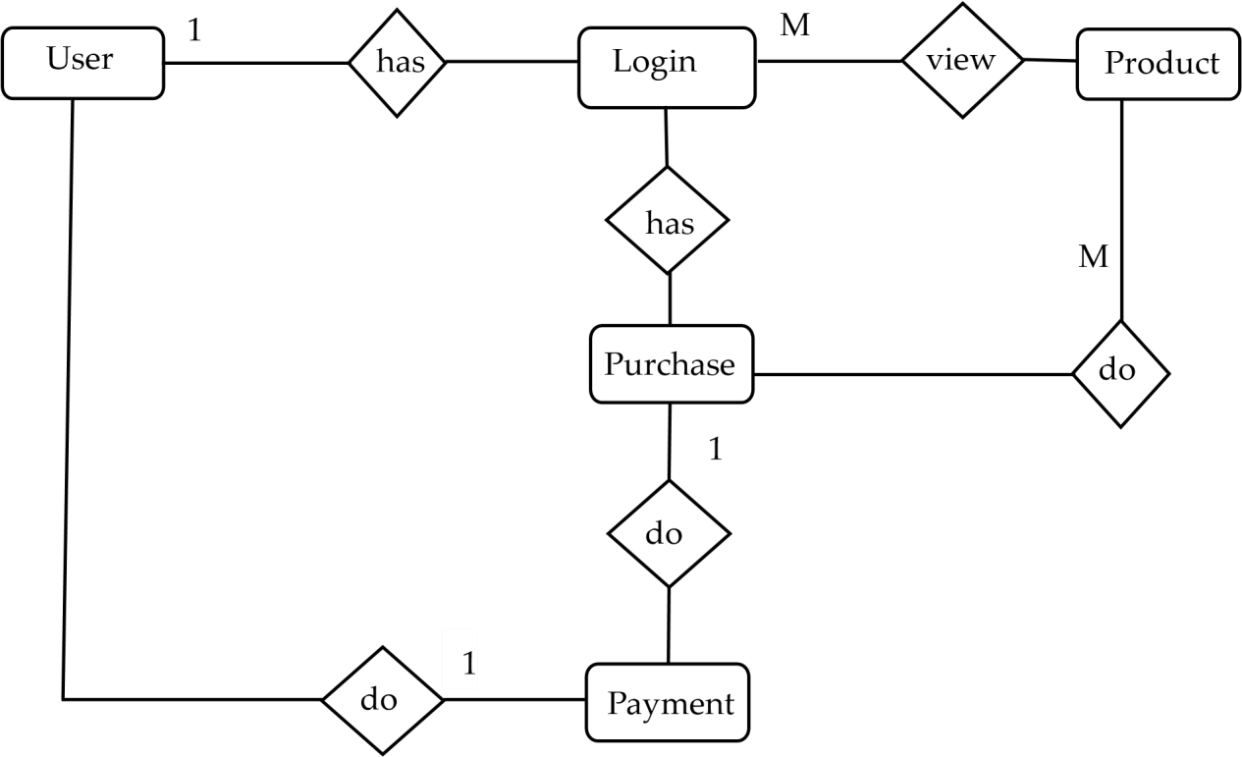

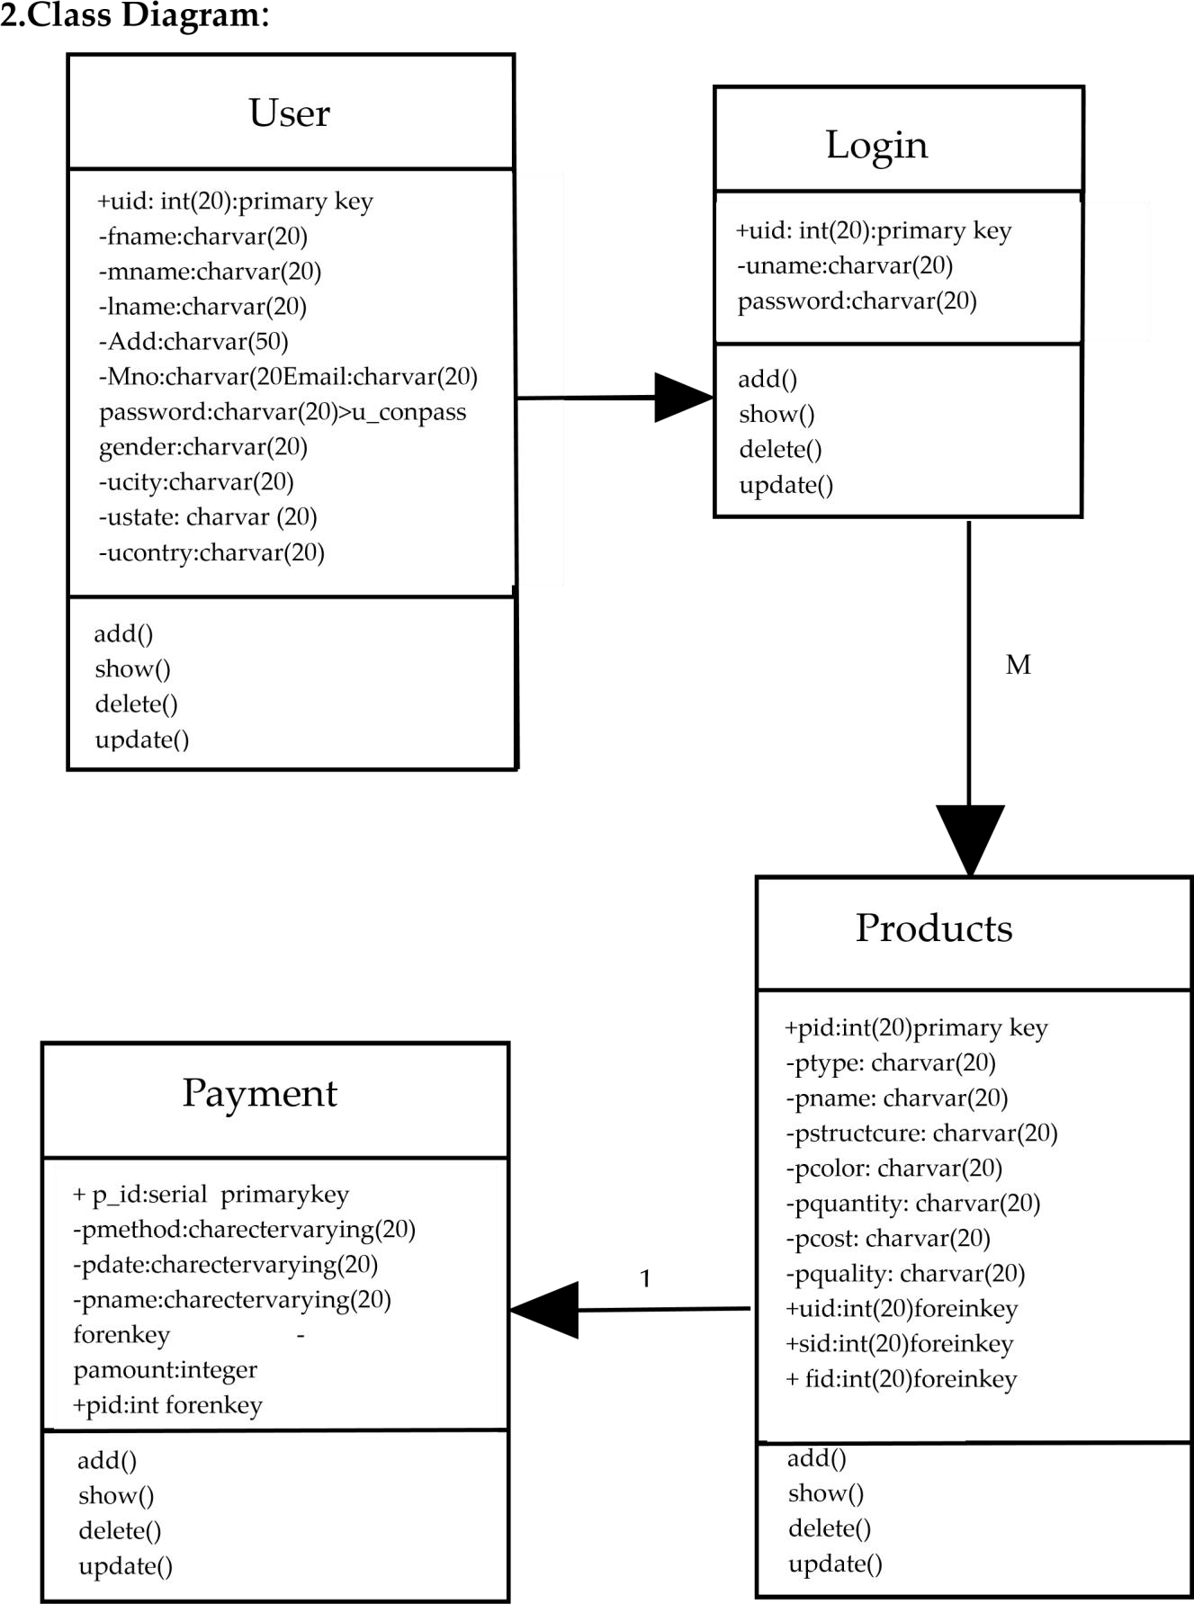

3.Use Case Diagram:
















User

Product

Details

Payment

Login

Farmer

System

Services

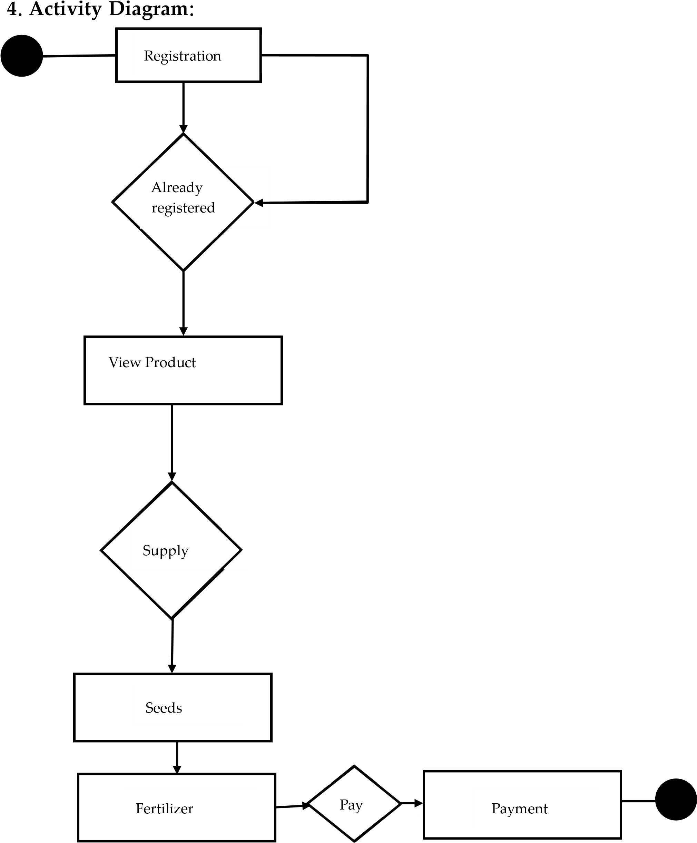

5.Sequence Diagram:

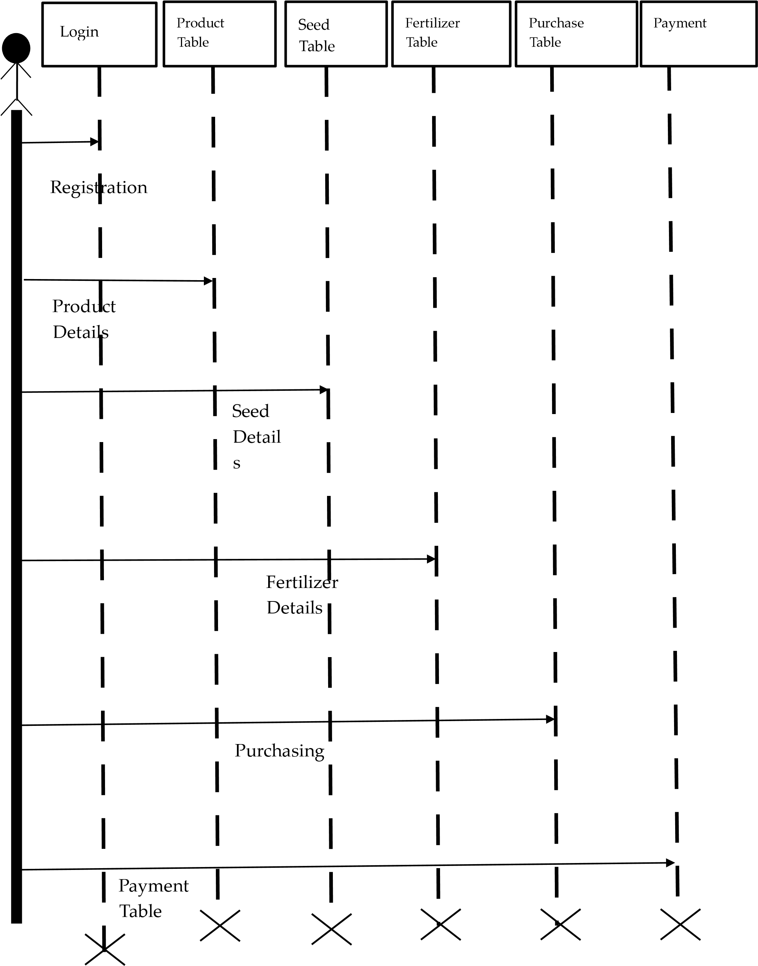
6.Component Diagram:
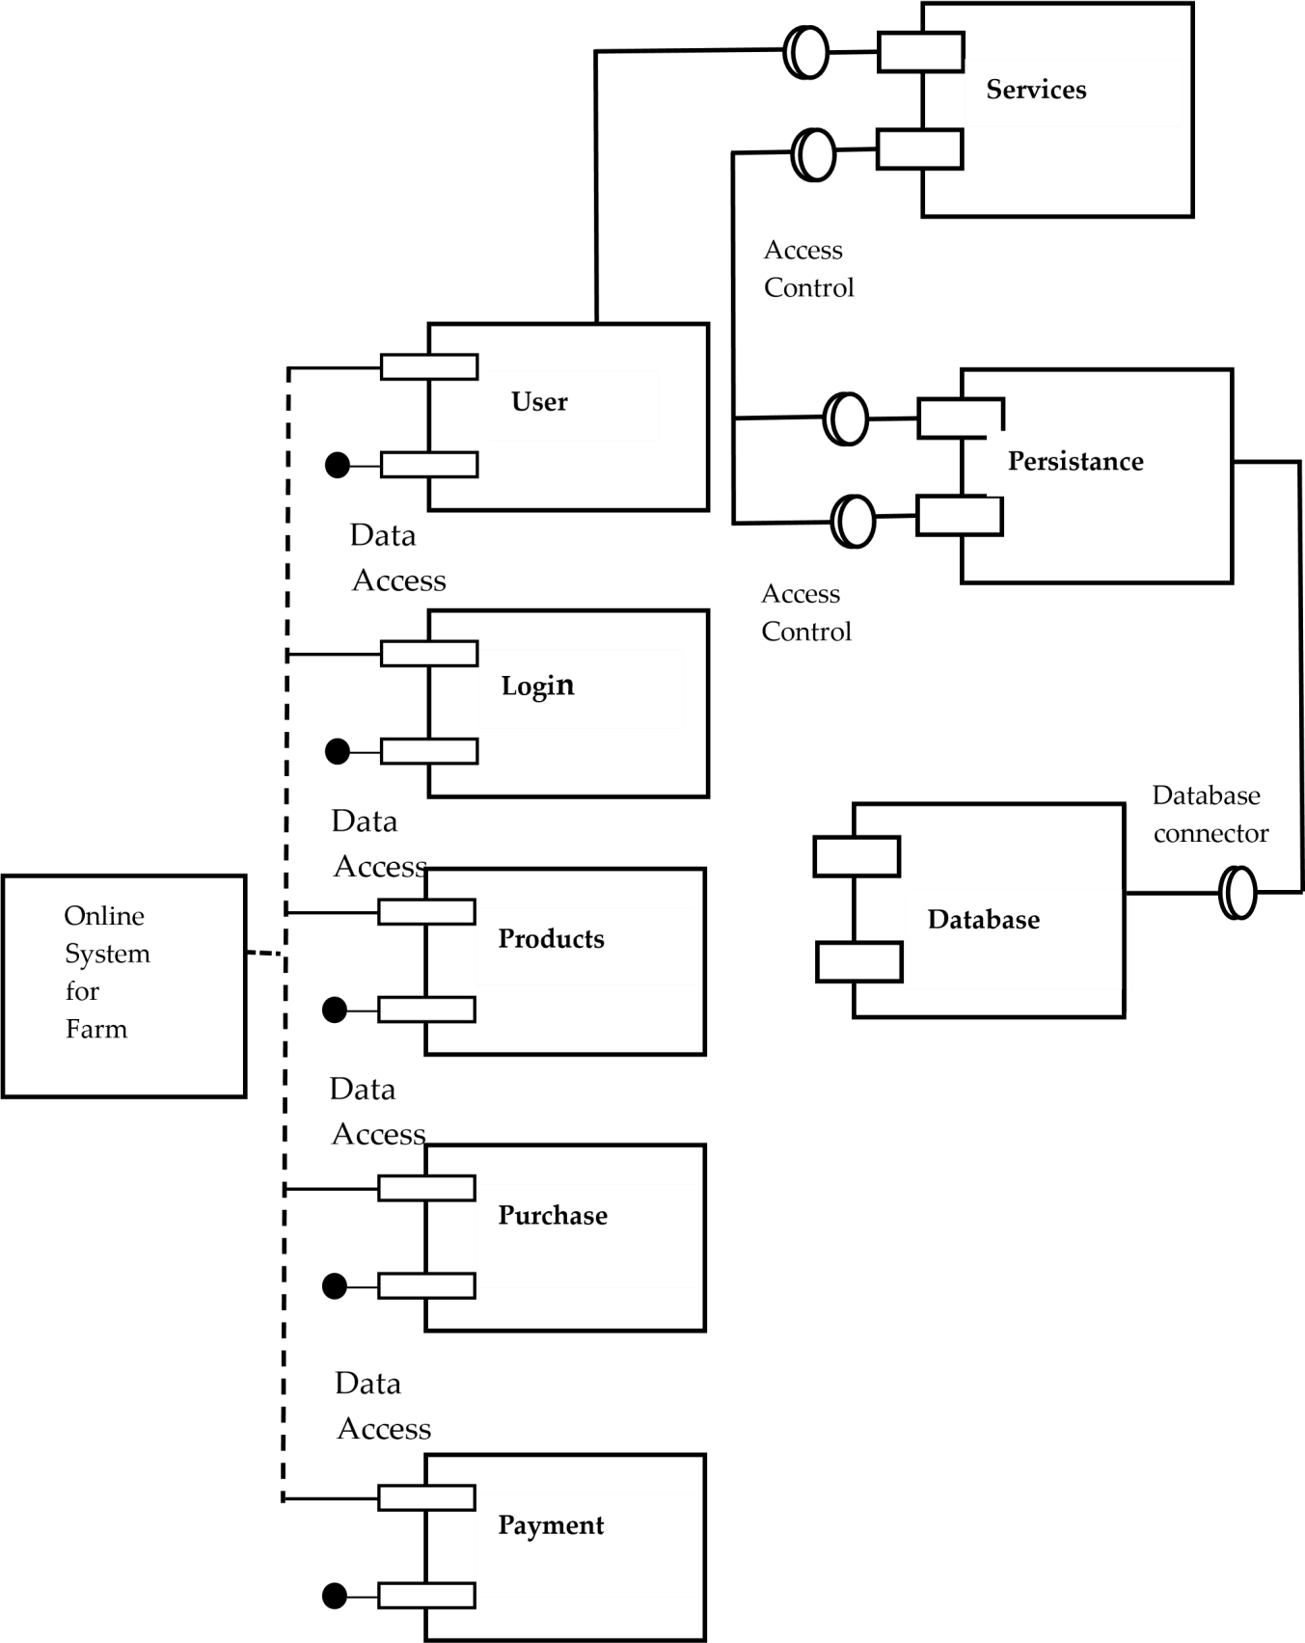
7. Deployment Diagram:
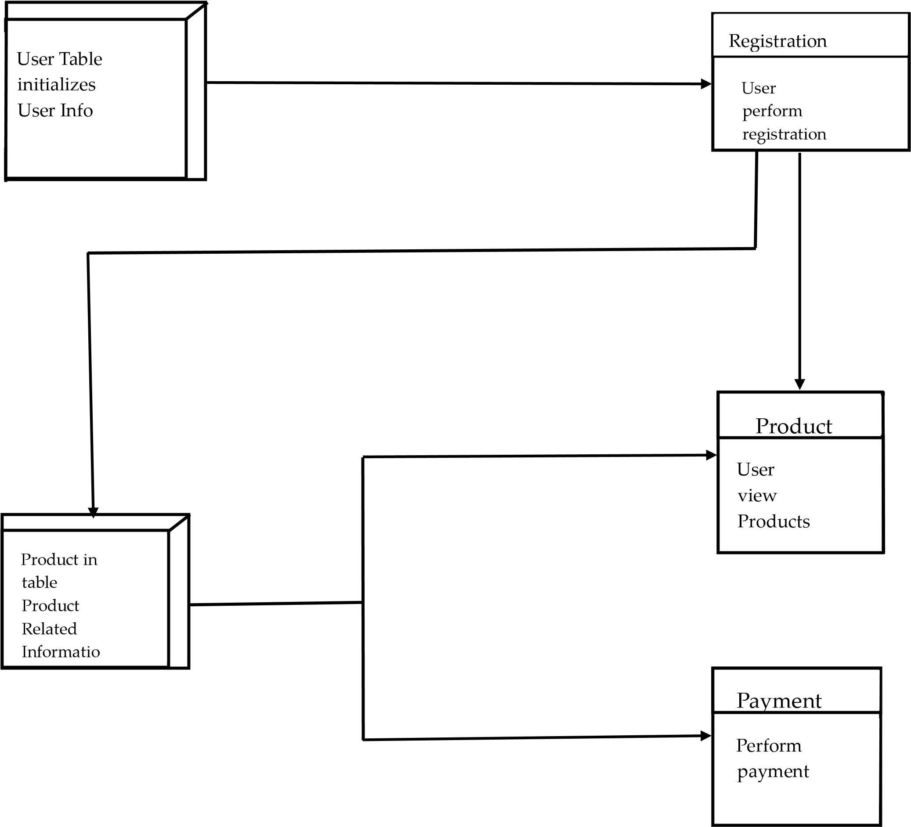

5.System Implementation: -
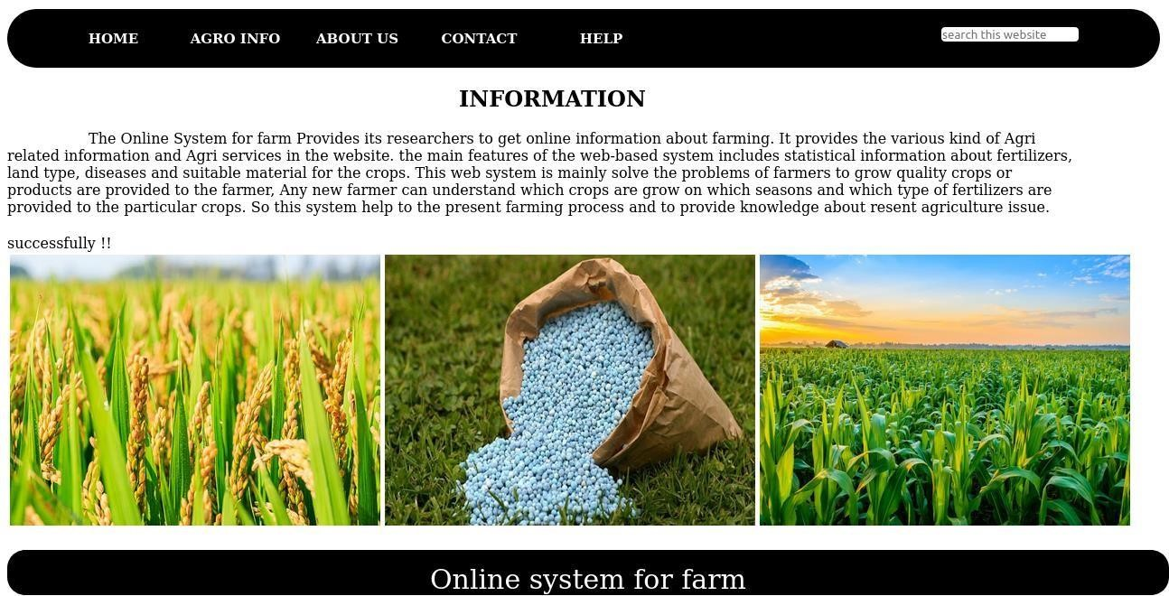

User login Registration: -

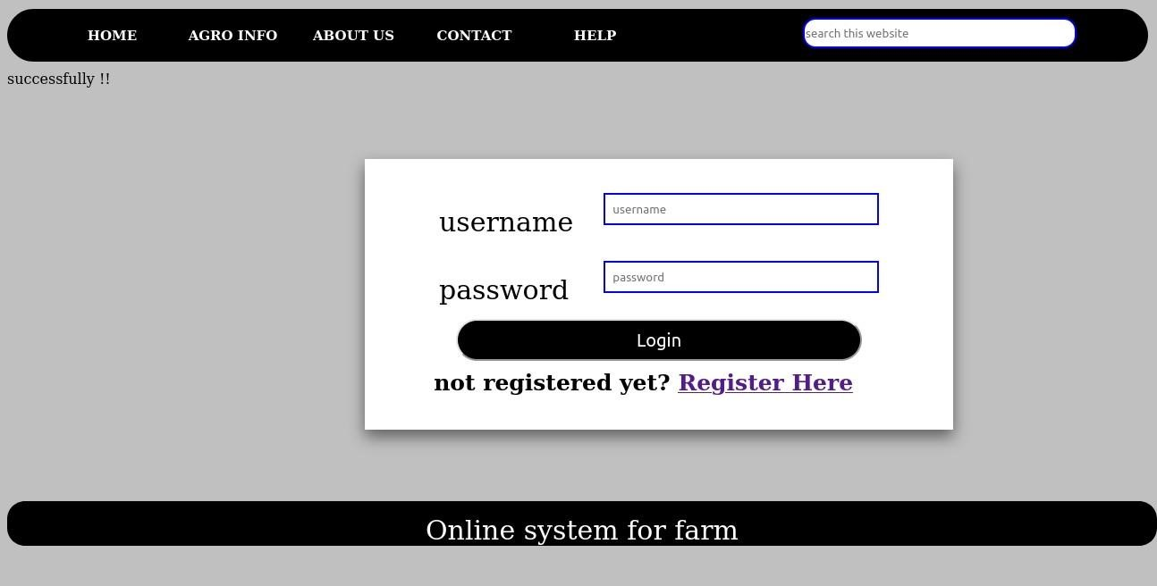

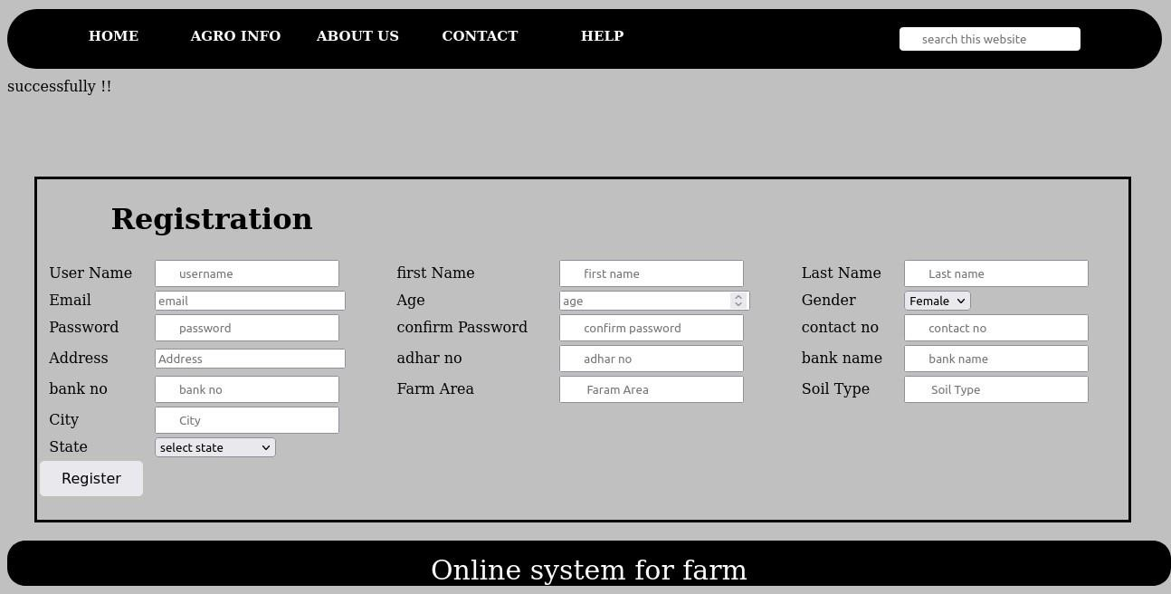

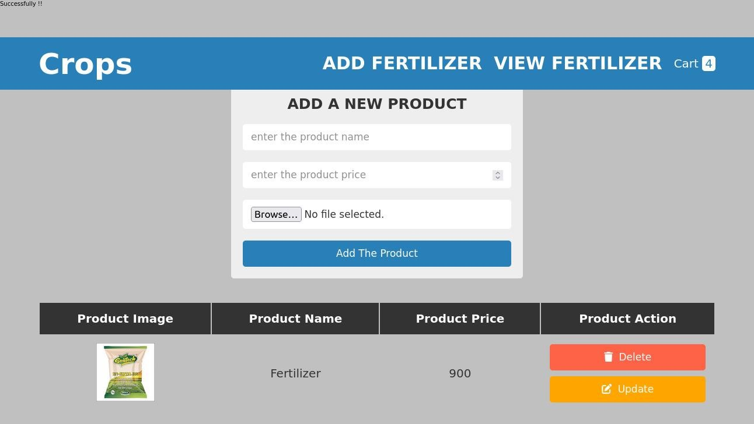

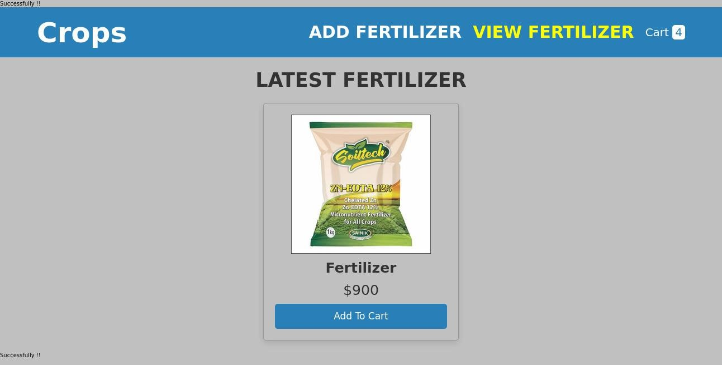

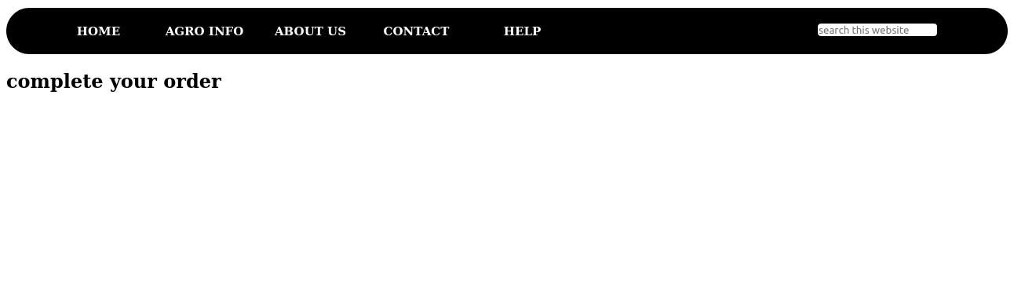

6. System Testing

- Defining Testing Plan:
System testing of software or hardware is testing conducted on a complete, integrated system to evaluate the system's compliance with its specified requirements. System testing falls within the scope of black-box testing, and as such, should require no knowledge of the inner design of the code or logic. As a rule, system testing takes, as its input, all of the "integrated" software components that have passed integration testing and also the software system itself integrated with any applicable hardware system(s). The purpose of integration testing is to detect any inconsistencies between the software units that are integrated together (called assemblages) or between any of the assemblages and the hardware. System testing is a more limited type of testing: it seeks to detect defects both within the "inter-assemblages" and also within the system as a whole.
System testing is performed on the entire system in the context of a Functional Requirement Specification(s) (FRS) and/or a System Requirement Specification (SRS). System testing tests not only the design, but also the behaviour and even the believed expectations of the customer. It is also intended to test up to and beyond the bounds defined in the software/hardware requirements specification(s).

- Implementing Testing Strategy: -
The following methods of testing were carried out to check correctness and reliability of the processing system.
- Unit Testing:
Unit testing for an online system for farm would involve testing the individual components of the system such as the user interface, data storage and retrieval, and any calculations or algorithms used by the system. This would ensure each part of the system works as intended and meets the requirements set out for it.
i. Unit Testing: Test Cases:

For Login:
Sr no | Input | Expected  Output | Actual Output | Result
1. | username in userfield | correct | User Login successfull | PASS
2. | username in userfield | incorrect | User cant Login-error message | FAIL
3. | user_pass in passwordField | correct | User Login successfull | PASS
4. | user_pass in passwordField | incorrect | User cant Login-error message | FAIL
5. | Login | Click | Login Sucessfully | PASS

d. Black-box Testing:
Black box (or functional) testing checks the functional requirements and examines the input and output data of these requirements. Black box testing, also known as behavioural testing focuses on the functional requirements of the software.
Black box testing for an online system for farm would involve testing the system from a user's perspective, without knowledge of the internal workings of the system. This would involve testing the system's user interface, functionality, and performance to ensure it meets the requirements set out for it. It would also involve testing the system's compatibility with different devices and browsers, and any external systems it interacts with.
Black box testing is a software testing method in which the internal
structure/design/implementation of the item being tested is not known to the tester.
- White-box Testing:
White box testing is a testing technique that examines the program structure and derives test data from the program logic/code. .
White box testing for an online system for farm would involve testing the code of the system to ensure it meets the required standards and specifications. This would involve testing the individual functions and modules of the system to ensure they work as intended and that the code is efficient, maintainable, and secure. It would also involve testing for any errors or bugs in the code.

- Alpha Testing:
Alpha testing for an online system for farm would involve testing the system internally to ensure it is ready for release to the public. This would involve testing the system in a controlled environment to identify any issues or bugs that need to be addressed before the system is released to the public. It would also involve testing the system with a small group of users to gather feedback and ensure the system meets user needs.

7. Conclusion And Future Plans
Conclusion: -
Our project is only a humble venture to satisfy the needs to manage their work. Several user friendly coding have also adopted. This package shall prove to be powerful package in satisfying all the requirements of the Online System For Farm.
The objective of software planning is to provide a frame work that enables our team to make reasonable estimates made within a limited time frame at the beginning of the software project and should be updated regularly as the project progress.
So for getting result within the time limits. The project can be completed with proper planning.

Future Plans: -
- We will host the platform on online servers to make it accessible worldwide.

- we will add online payment options.
- We can improve the servers and we can add more services.

8.Bibliography and Reference
Websites.
- https://www.growag.com
- https://agricoop.nic.in
- https://krishi.maharashtra.gov.in

